Emergency
Action Plan

Scripps Institution of Oceanography
Region 11

This document is a detailed procedure of actions to be taken in the event of an emergency. It is to be used concurrently with the UCSD Emergency Response Guide and building Emergency Evacuation postings located in every building. Whether responding to a small incident or a large emergency, building occupants should follow these important steps to prevent injury and minimize the loss of research equipment and infrastructure. Safety is everyone’s responsibility.

Basic Emergency Procedures

COMMUNICATE THE SITUATION:
In the event of an emergency, make a quick assessment of the situation.
MINOR INCIDENT
If determined to be a minor incident, control the situation, notify your immediate supervisor and/or PI, and then report it to a Key SIO Personnel (see below).

MAJOR EMERGENCY
If it is an active emergency affecting the immediate work area, building or other SIO buildings, call campus police at 911 from any campus phone (or 858-534-4357) to report a fire or to request police or emergency medical assistance.

Other numbers:
Env. Health & Safety (e.g. chemical spill) (858) 534-3660
Physical Plant Repair/Maintenance (858) 534-2930

If reporting an emergency, calmly state:
- Your name and location of the emergency (building/room).
- Nature of the emergency; fire, chemical spill, etc.
- Injuries? Hazards which may affect responding emergency personnel?
- A phone number near the scene where you can be reached.

After calling 911, report the situation to a member of the SIO Facilities Group:

Key SIO Personnel
Name | Position / Role | Office | Mobile
Allyson Long | Scripps Safety Coordinator | ext. 48449 | 858-210-1764
Dennis Brand | Facilities Manager | ext. 42730 | 858-568-6643
Jose Hernandez | Facilities Assistant | ext. 63160 | 858-291-3616
Dennis Bithoulkas | EH&S Research Assistant Specialist | ext. 21872 | 858-583-3271

DESIGNATED AUTHORITY:
Person contacted above is in charge of emergency situation until relieved of responsibility by a superior or by responding emergency personnel.
Other UCSD Emergency Phone Numbers
Thornton Emergency Room | (858) 657-7600
Hillcrest Medical Center Emergency Operator | (858) 534-4357
Poison Control Center | (800) 876-4766
Telephone/Data/Repair Service | (858) 534-3187
UCSD Campus Emergency Status Phone | (888) 308-UCSD (8273)

Building Evacuation
- If a fire alarm or designated authority calls for evacuation, quickly move outside of the building using the nearest safe stairway and doors marked with an EXIT sign.
  - On your way out close and secure all windows and doors, pull the fire alarm, and alert others to evacuate.
  - Take your keys and your personal belongings with you.
  - Help any that need special assistance – disabled, small children, etc.
- Report immediately to the building specific Designated Assembly Area (see green box on the Evacuation Map posted in your building).
- Listen for roll call / headcount. (A Building Safety Contact should conduct a roll call from building roster.) Report any missing persons and last known locations.
- STAY PUT and wait for instructions from emergency response personnel.
- Do not re-enter the building until authorized to do so. Do not return to search for missing people or personal items.
- Keep yourself and others around you calm.

Earthquakes
During Heavy Shaking
- Duck, Cover and Hold On.
- Get under a desk, table or stairwell. If none are available, move against and interior wall and cover your head with your arms. Remain under cover until the movement subsides.
- Stay away from large windows, shelving systems or tall room partitions.
- After the shaking has stopped, survey your immediate area for trapped or injured persons and ruptured utilities.
- Evacuate the building. Move to the building specific Designated Assembly Area (see green box on the Evacuation Map posted in your building) and await further instructions from emergency personnel.
  - Everyone must go to the evacuation site before leaving campus to report three things: where you are going, when you are going, and how you will be getting there. Our goal is to make sure everyone is safe and accounted for. We will let everyone leave the campus as quickly and safely as possible

Tsunami or Tsunami Warning
Southern California’s low-lying coastline could experience tsunami waves, either from a distant earthquake or locally generated by our own seismically active geology. Know the Tsunami Warning Center Terms:
- Advisory: An earthquake has occurred in the Pacific basin and might generate a tsunami. Tsunami Warning Centers will issue hourly bulletins about the situation.
- Watch: A tsunami was or may have been generated, but is at least 2 hours travel time to the area under watch status.
- Warning: A tsunami was or may have been generated and could cause damage. People in the warned area are strongly advised to evacuate to higher ground.

In case of a Tsunami warning triggered by a distant seismic event
- Stay off beach and Pier, move to higher ground
- Be alert to announcements on radio/TV, Triton Alert and from emergency responders

In the case of a strong local earthquake, the ground shaking is considered warning of potential tsunami risk at the coast, and people should immediately seek higher ground. In this situation, Pawka Green and other normally designated assembly areas at less than 25 feet elevation are not considered safe; people should move to higher ground. The Eckart building entrance and outdoor deck are at 30 meters elevation, which is considered not at risk of inundation.

Fire Procedures
In Case of Small Fire
- Pull the fire alarm and call Campus Police at 911 or from a cell phone call 858-534-HELP (4357).
- Alert people in the area to begin evacuation. Stay upwind from the fire.
- To use a fire extinguisher:
  - Keep an exit available behind you and bring the extinguisher within six feet of the fire.
  - Pull the pin
  - Aim at the base of the fire
  - Squeeze the handle
  - Sweep side to side, at the base of the fire until it is out or the extinguisher is empty
In Case of Large Fire
- Pull the fire alarm and call Campus Police at 911 or from a cell phone call 858-534-HELP (4357).
- Alert people in the area to begin evacuation. Stay upwind from the fire.
- Close doors and windows to confine the fire.
- Move to the Designated Assembly Area (see green box on the Evacuation Map posted in your building) and await further instructions from emergency personnel.
- Have persons knowledgeable about the incident and location assist emergency personnel.

Building Lockdown
- REMAIN CALM. The situation will be dynamic, changing from moment to moment. STOP and THINK about measured and reasonable response given the information known.
- Close and quickly move away from windows.
- If possible, move to an area that will allow exit from the building. Close and secure all doors. Take your keys with you.
- Help any that need special assistance – disabled, small children, etc.
- Call the Campus Police at 911 or from a cell phone call 858-534-HELP (4357). Inform them where you are and how many are present.
- STAY PUT and wait for instructions from emergency response personnel.

Shelter In Place
- There may be situations when it is simply best to stay where you are and avoid any uncertainly outside. This can be everything from hazardous materials, to fires, to weather related events, chemical spill, or explosions.
- Select or move to an interior room with few or no windows that can be locked.
- It’s ideal to have a hard-wired telephone in the room you select as cell phone towers/repeaters may be overwhelmed or damaged in an emergency.
- Lock all available doors and turn off fans, heating & air conditioning if possible.
- Depending on the situation and campus protocol along with information from lead agencies, a Triton Alert Notification may or may not be sent to the campus.

Acts of Violence
- Confronted by a Violent Person:
  - Try to maintain a calm demeanor and do not allow yourself to be alone with the person, if possible.
  - Utilize any procedures you have in place to alert someone in the office to call police at 911.
  - Do what you can to remain calm and de-escalate the person until police arrive.
  - If the threat is not in your immediate area, follow the Evacuation or Building Lockdown procedures above. You will have to decide which option to take.
- Active Shooter
  - Lock or barricade the door. Block the door using anything available.
  - Stay behind solid objects away from the door as much as possible.
  - Consider trying to escape.
  - If possible, call 9-1-1.

Area Safety Coordinators (ASC) & Lab Managers: Always keep a copy of the Emergency Action Plan and a current lab roster attached to a clipboard with a pen ready to go. Make sure to grab these items, along with keys, before you evacuate the building. Regroup with building occupants and your lab personnel at the building’s Assembly Area noted on the emergency evacuation maps.

Building Occupants: Once at the Assembly Area, find your Area Safety Coordinator (ASC) or lab manager. They will record the names of all present and missing lab personnel, along with a damage assessment of the lab. ASC’s or Lab Managers will deliver this information to the Building Safety Contact, who is responsible for gathering information from ASCs and Lab managers.

Emergency Evacuation Maps
Please consult the evacuation maps posted near the exit of your building for directions from your floor/room.

Page 7 Center For Coastal Studies
Page 8 Deep Sea Drilling East and West
Page 9 Eckart Building
Page 10 Hubbs Hall
Page 11 Hydraulics Laboratory
Page 12 IGPP Munk Laboratory
Page 13 IGPP 1000 Revelle Laboratory
Page 14 IGPP 2000 Revelle Laboratory
Page 15 IGPP 3000 Revelle Laboratory
Page 16 IGPP 4000 Revelle Laboratory
Page 17 Isaacs Hall
Page 18 Kaplan Lab
Page 19 Keck Center (OAR)
Page 20 Marine Science Development Center
Page 21 New Scripps Building
Page 22 Nierenberg Hall
Page 23 Old Scripps Building
Page 24 Ritter Hall
Page 25 Scholander Hall
Page 26 Seaside Forum
Page 27 Seaweed Canyon
Page 28 Spiess Hall
Page 29 Sverdrup
Page 30 T-25, T-30, T-31 Cottages
Page 31 Vaughan Hall

CENTER FOR COASTAL STUDIES

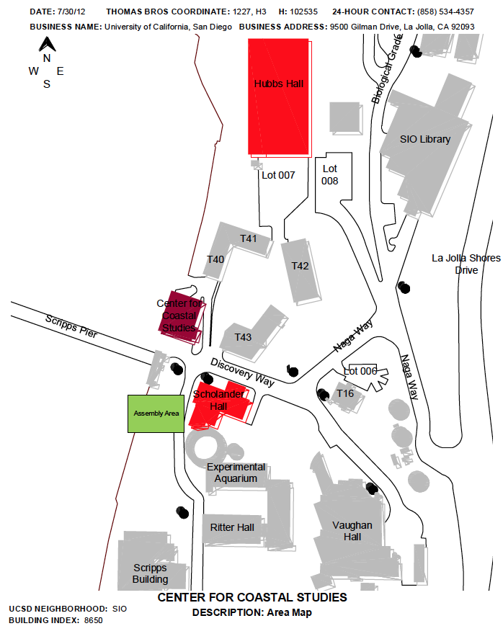

DEEP SEA DRILLING WEST & EAST

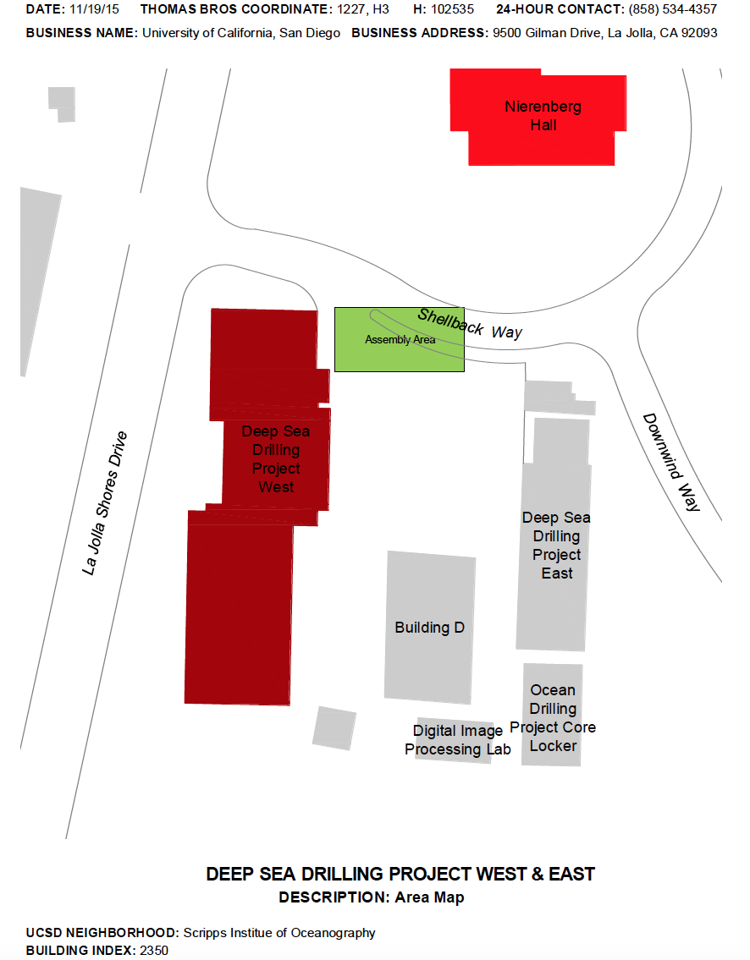

ECKART BUILDING
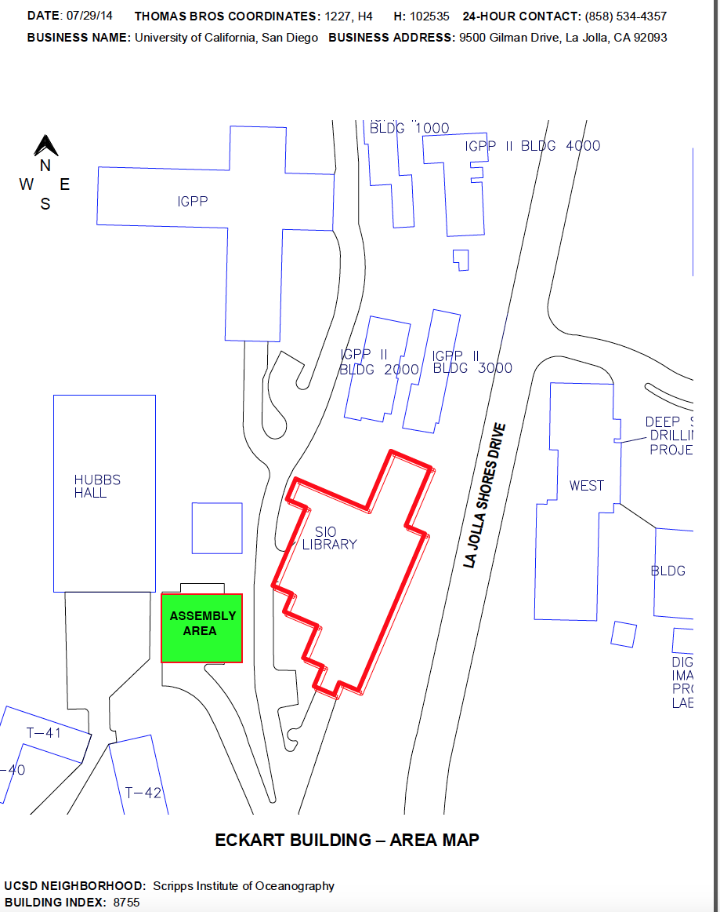

HUBBS HALL

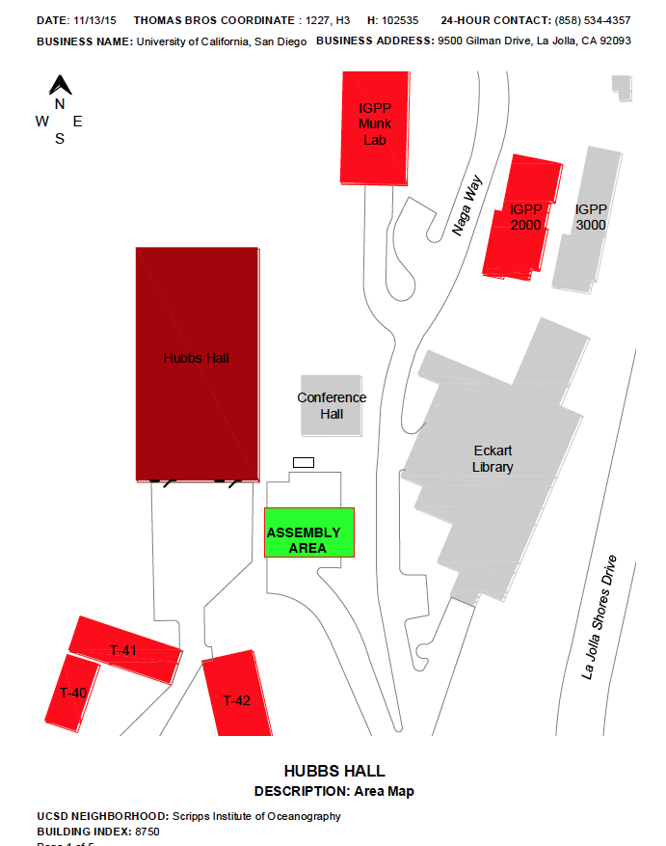

HYDRAULICS LABORATORY
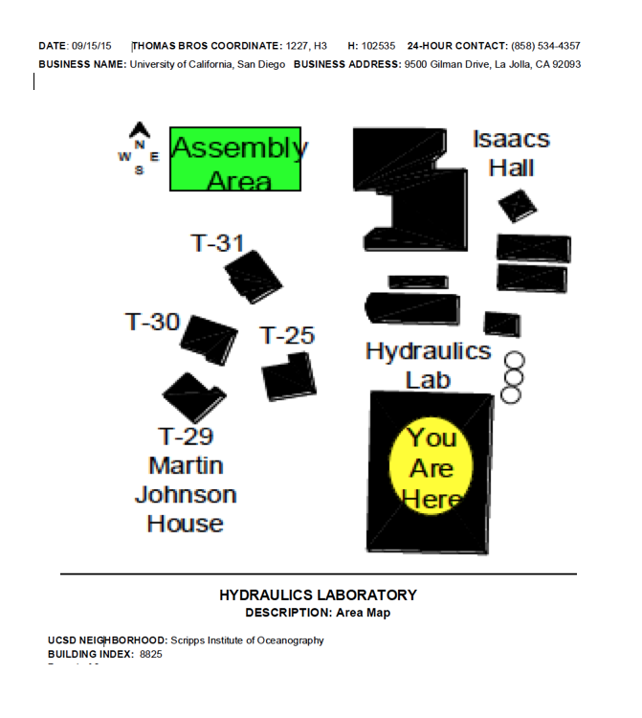

IGPP MUNK
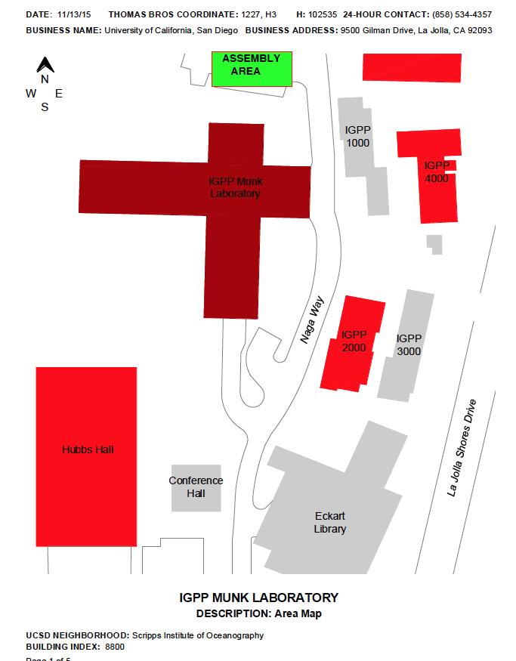

IGPP 1000
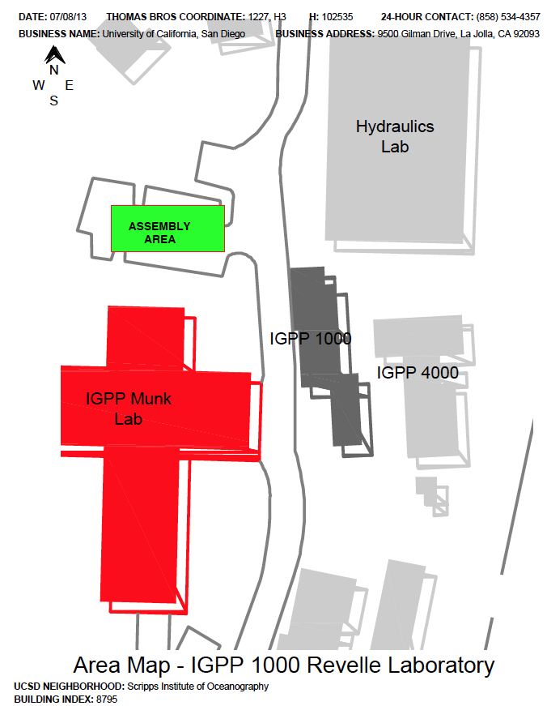

IGPP 2000

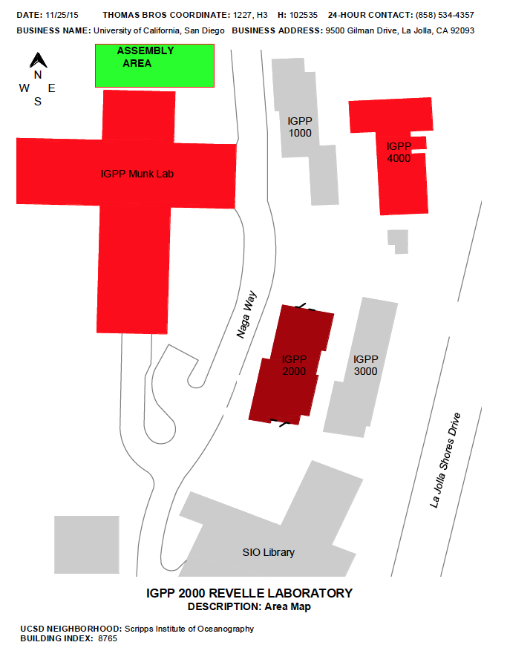

IGPP 3000

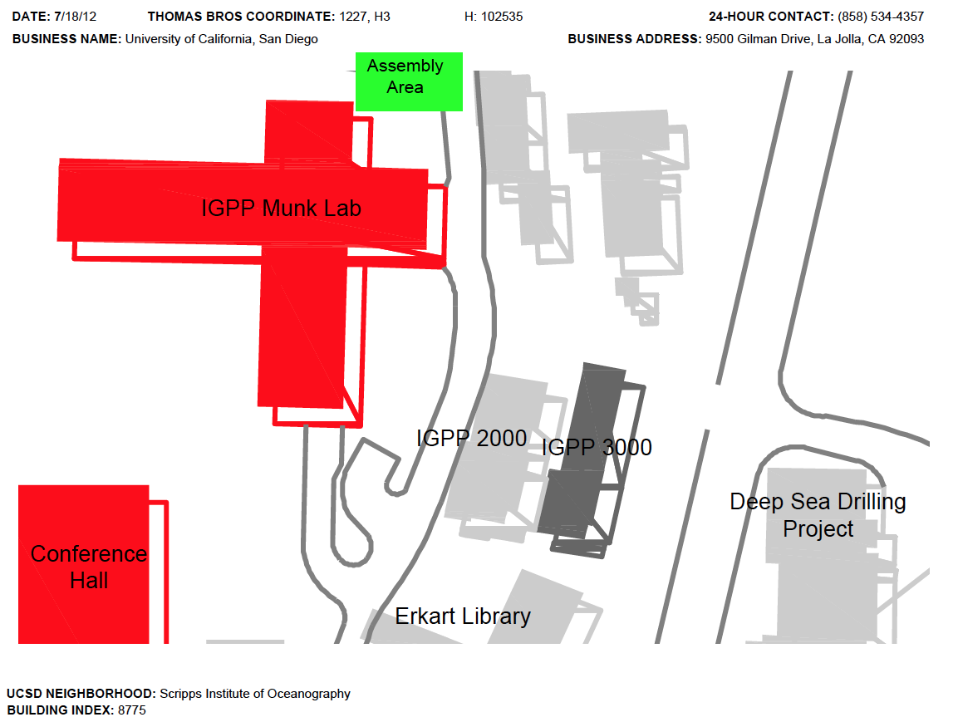

IGPP 4000
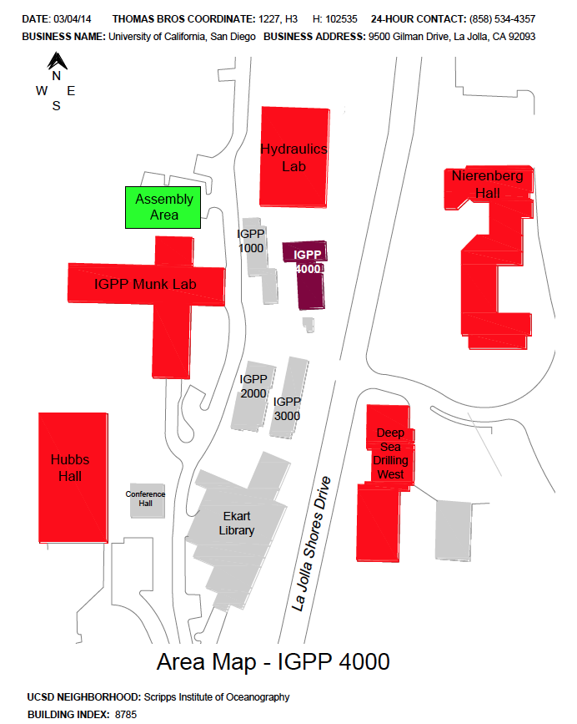

ISAACS HALL
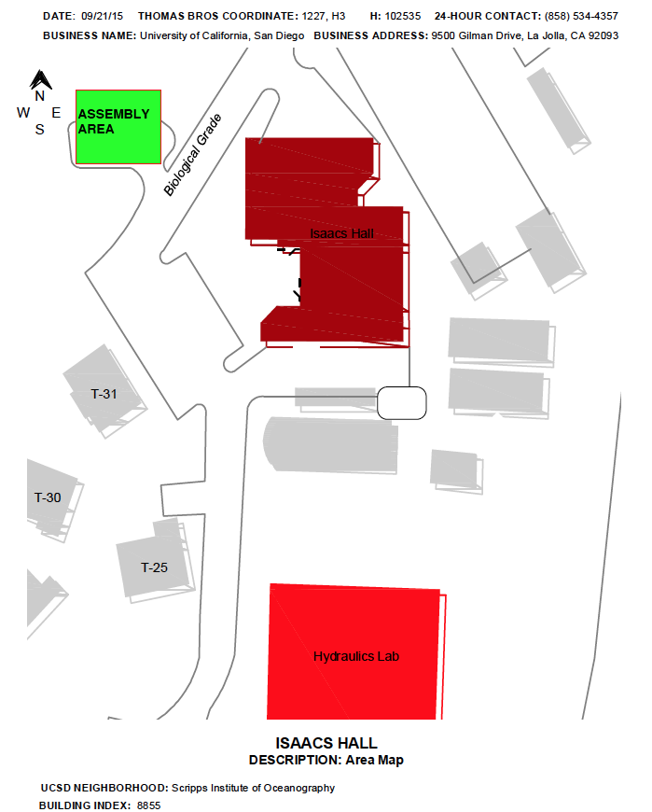

KAPLAN LAB
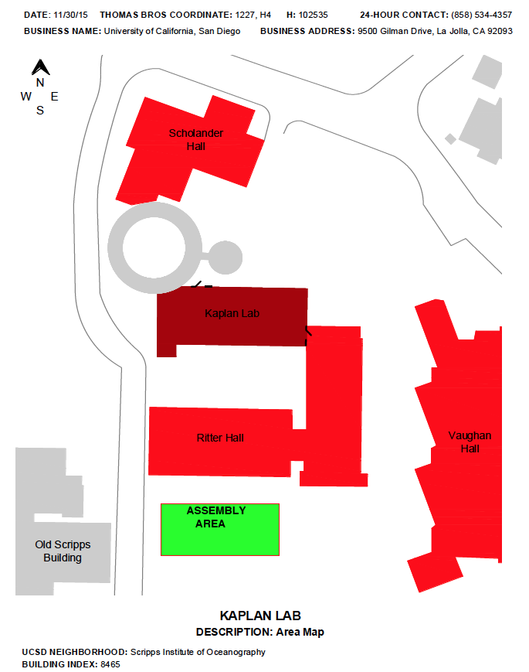

KECK CENTER
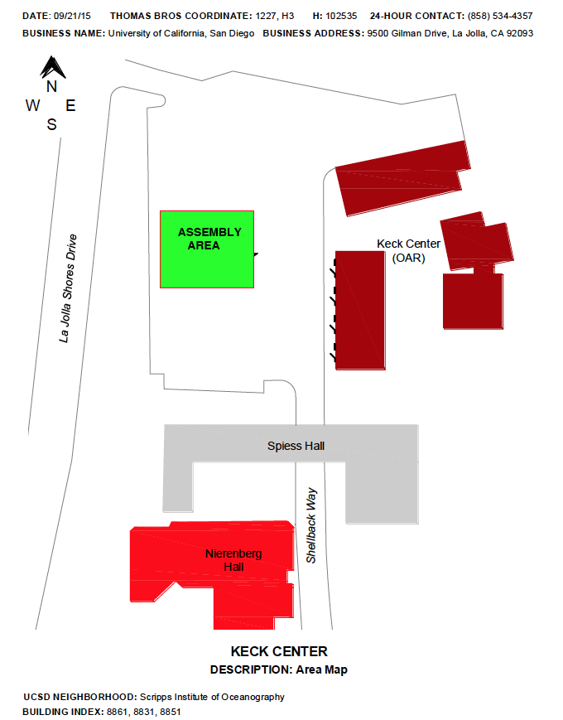

MARINE SCIENCE DEVELOPMENT CENTER
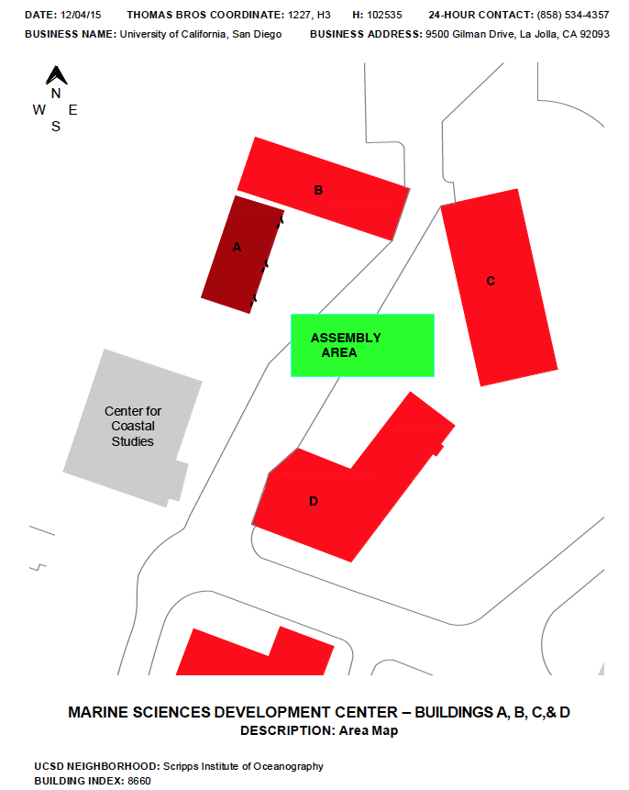

NEW SCRIPPS BUILDING
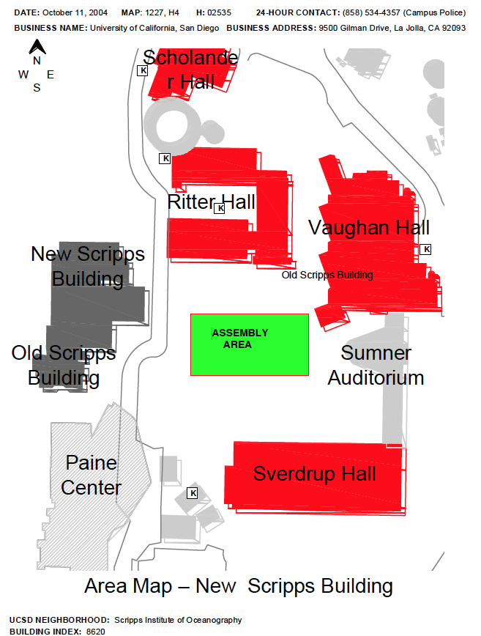

NIERENBERG HALL

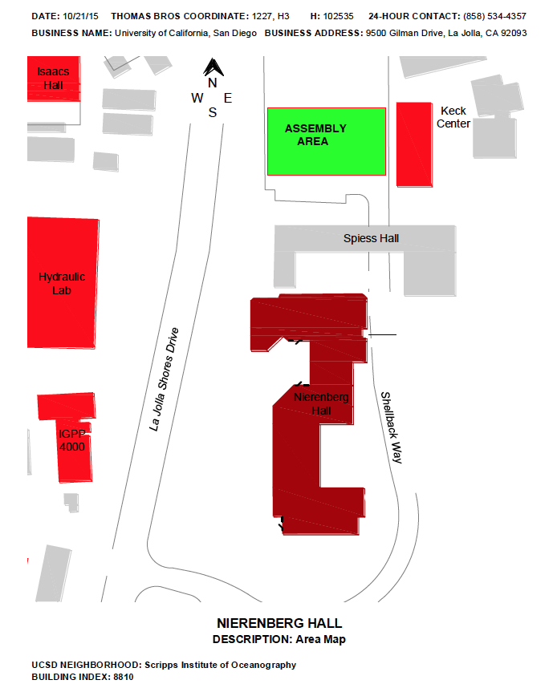

OLD SCRIPPS BUILDING

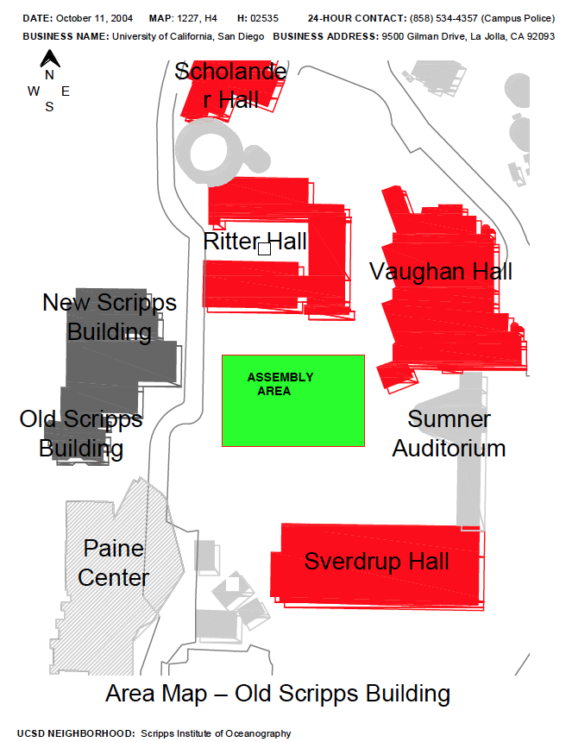
RITTER HALL
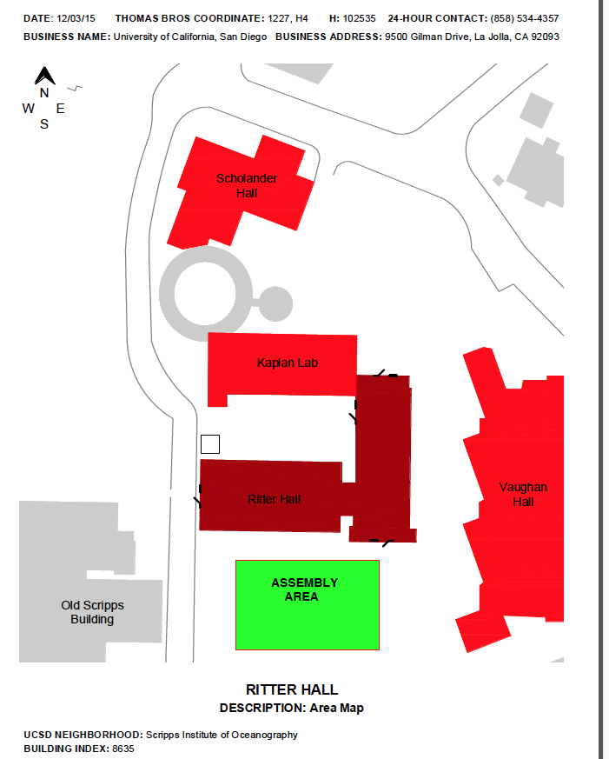

SCHOLANDER HALL
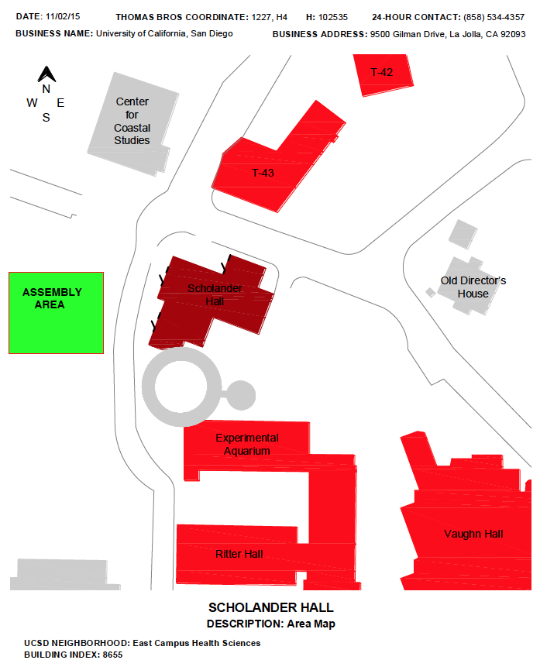

SEASIDE FORUM
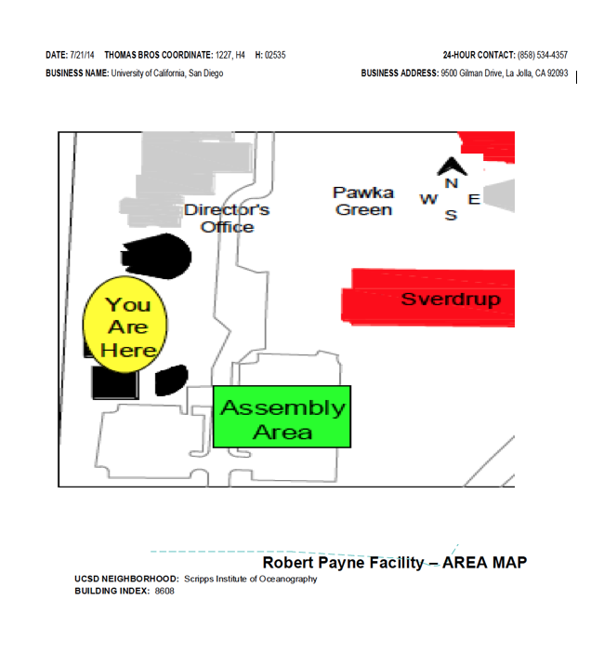

SEAWEED CANYON
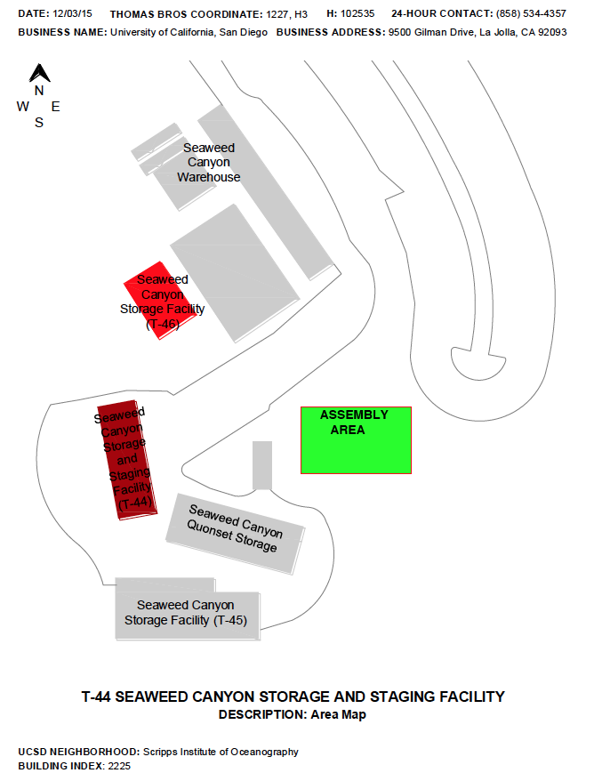

SPIESS HALL
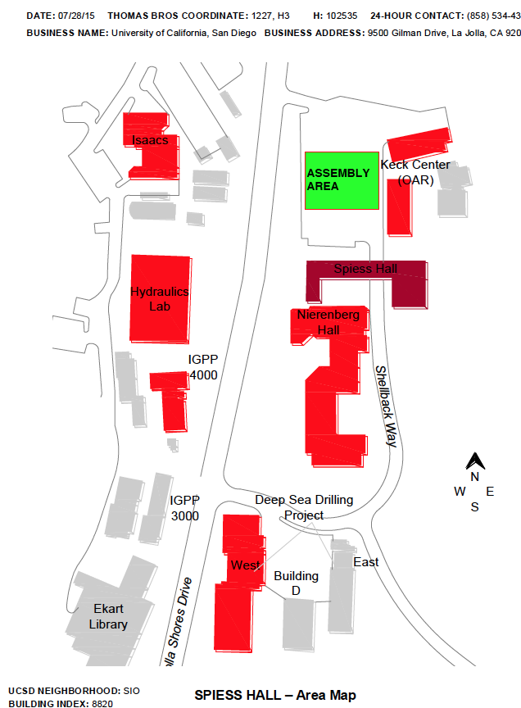

SVERDRUP
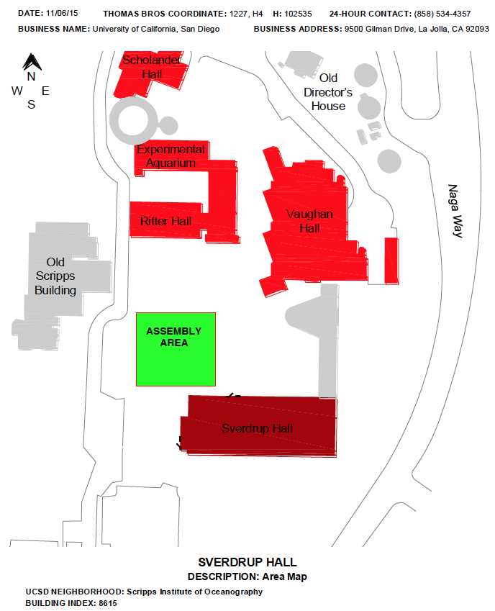

T-25, T-30, & T-31 COTTAGES
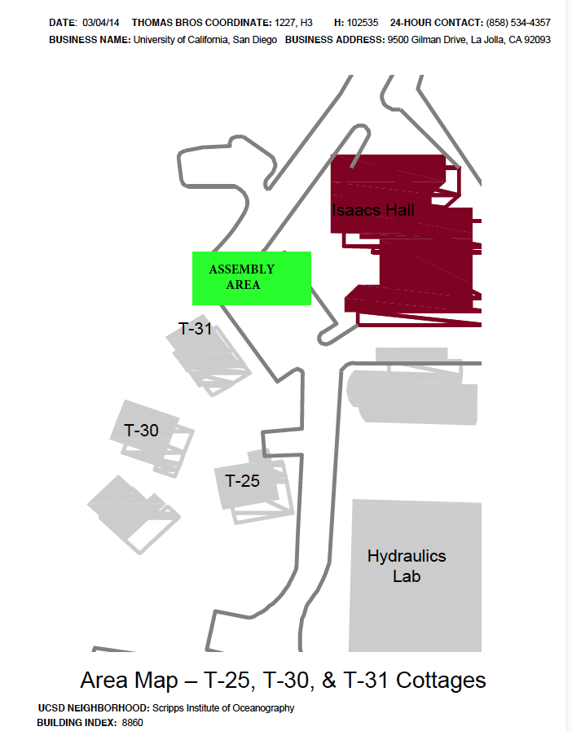

VAUGHAN HALL
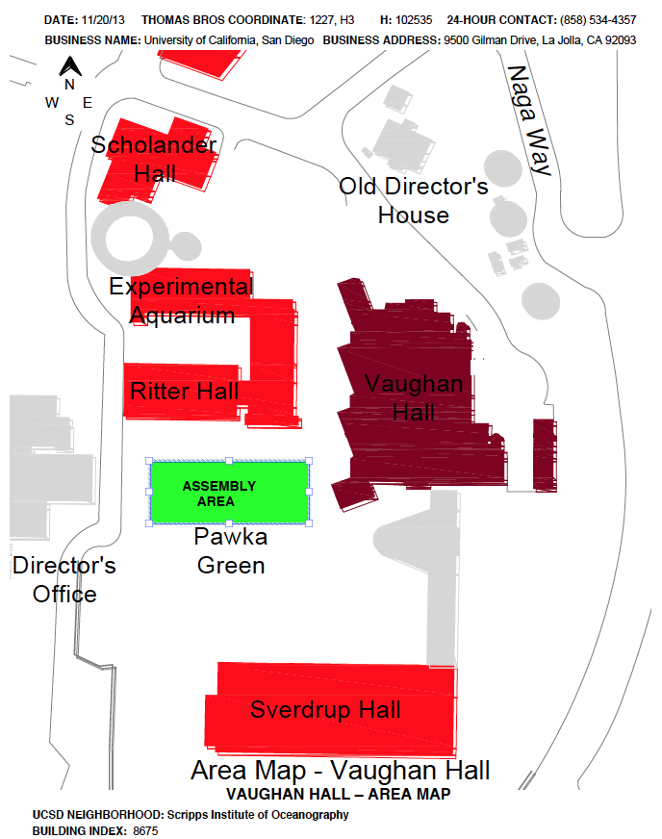

EAP Annual Review Declaration

Review Date | Plan Amendment |  | Name and signature of person authorized to review this Plan
 | Will Amend | Will Not Amend

EAP Amendment Log
Page/Section of Change  Or Annual Review | Description of Change | Initials/Date
Page 2 | Removed Ken Hall from Key SIO Personnel listing and replaced with Dennis Brand, Facilities Manager. | AL/12.15.16
 | No changes needed. | AL/1.30.18
Page 2  Page 3  Page 5 | Removed Gary Wellwood from Key SIO Personnel listing and replaced with Jose Hernandez, Facilities Assistant. (pg 1)  Edited Building Evacuation section to remove emergency bags and replace with personal belongings.  Edited Building Occupant section to remove Building Safety contact as a volunteer staff role. | AL/11.8.18

