SIO128
Microbial Life in Extreme Environments
Prerequisites: BILD1-3 or consent of instructor
Grading options: Letter or S/U

Instructor Contact Information:  Douglas Bartlett  Cell Phone: 858-663-0230  Email: dbartlett@ucsd.edu  Office Hours: just email me  Class location:  Cognitive Science Building,  room 2  Day and time:  M, W, F 10:00 – 10:50 AM | Teaching Assistants Contact Information  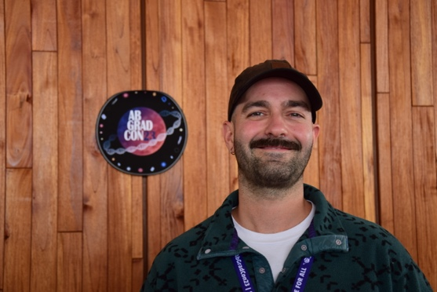  Miguel Desmarais  Email: mdesmarais@ucsd.edu  Office Hours: TBD  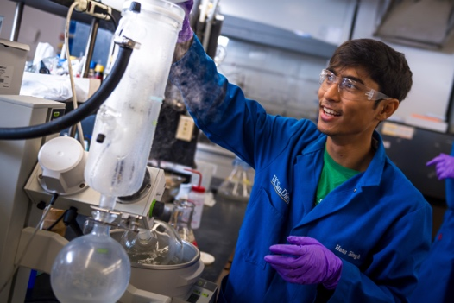  Hans Singh  E-mail: hwsingh@ucsd.edu  Office Hours:TBD

This course will highlight the weird and wonderful things microbes do to influence our lives and the characteristics of Earth. It is hoped that by highlighting the strangest of the strange that students will acquire a lifelong sense of fascination and wonder with the nature and diversity of the largely invisible microbial life forms present throughout the biosphere. Examples will include microbes in bubbling sulfuric acid versus those that live in ice inclusions, upper atmosphere ecosystems, mineral precipitations, bacteria with rocket fuel in their membranes, giant microbes in fish guts, the viruses of viruses, radiation resistance in the Atacama desert, microbes that live off of the effects of radioactive potassium, how microbes that like high pH got into your laundry detergent, microbial survival for millions of years in amber, brine inclusions and deep subsurface sediments, and the connections between extremophile microbes on Earth and the possibility of life elsewhere in the solar system.

Course Objectives
By the end of this course you will be able to
(1) describe the upper boundaries of life
(2) wax poetic about the vast diversity of habitats in which life is or may be found
(3) explain the physical-chemical basis of environmental stresses to life
(4) understand the many largely undescribed divisions of microbial life
(5) argue the different possibilities for the origin and distribution of life

Required Reading
Lecture powerpoints and notes will be provided in our Canvas course website. In addition, for many of the lectures review articles will be provided. You are expected to familiarize yourself with all documents added to the course website (unless explicitly indicated to be just for your personal edification).

All lectures will be recorded.

Grading: 200 points total
Participation – 10 points
Quiz (only the highest scoring quiz will be counted) – 10 points
First Exam – 75 points
Second Exam (during final exam week) – 75 points
Extremophile microbial species powerpoint presentation – 5 points
Extremophile report – 25 points

Grading Policy
Grading will be based on a curve taking into account past student performances.

Participation
This is based on iClicker Cloud responses during class periods. Either mobile devices with the iClicker student App or iClicker remotes can be used. The course name is SIO128 (https://join.iclicker.com/CZMK). The following links may be useful to some of you: creating a free iClicker student account, registering an iClicker remote, and using the iClicker app. Make sure to have your iclicker registered with your ucsd email address. You will need to pay for your iClicker accounts, as we do not have a site license. The bookstore sells physical iClickers that come with a 5-year mobile subscription (~$50). Alternatively, students can purchase a mobile student license a la carte on iClicker's website at https://www.iclicker.com/pricing#student-pricing. They have a 6 month, 1 year, 2 year, and 4 year subscription.

Quizzes and exams
These will require multiple choice, true/false and short answer responses. The final exam is not comprehensive but rather is based on the material covered since the midterm exam. All quizzes and exams are in person.

Presentations
Each student will select a type of bizarre (aka extremophilic) microbial species or an extreme environment where life is either known or postulated to exist. Guidance on topic selection are present in the Extremophiles Report section of the class website, along with some examples of past reports. Student selections should be uploaded on the Google signup sheet present in the Extremophiles Report section of the class website. Presentations or reports that focus on disease processes are not permitted. For the presentation students addressing the same or a related topic will work in pairs, based on their preferences, or if needed, based on assignments made by Prof. Bartlett or the TAs. Each team will prepare one powerpoint or pdf consisting of two slides (no title slide, or list of references, or anything more than two slides is permitted). The first slide will be visually stunning and indicate in a few bulleted points what is remarkable about the selected microbe or habitat. Find a striking image that highlights the story you want to tell. If it describes a microbe or habitat presented in the course the description should go beyond the information provided in the slides/notes. The second slide will provide one figure or table from the scientific literature which highlights a key feature of the microbe or habitat. One member of the pair will present the first slide and the second member will describe the second slide. This should be a well-coordinated tag-team operation. Each presenter must limit their time to less than one minute. Each pair is thus limited to less than 2 minutes – so be succinct. Extremophile presentations are due no later than the night before your presentation. They should be e-mailed to Professor Bartlett at dbartlett@ucsd.edu, Miguel Desmarais at mdesmarais@ucsd.edu, and Hans Singh at hwsingh@ucsd.edu. Make sure to send the pptx or pdf file to all of us. Title the slide with the last names and first name initials of the two presenters, such as GarciafJonesr.pptx or GarciafJonesr.pdf. We will begin these presentations at the start of class on April 26. Throughout the remainder of the course we will start each class with 4-5 presentations.

Reports
Unlike the presentations the reports must represent an individual effort. Students will elaborate on the selected microbe or habitat or biochemistry in a 5 page single-spaced report (Times 12 point font with 1 inch margins). It should include a title and the student’s name and be divided into a 150-200 word abstract indicating the key points of the paper, with the body of the report subdivided into introduction to the topic, 3 subtopic headings, and a concluding paragraph, with 3-5 figures and/or tables, and a list of 6-12 references. All of this, including the list of references, is included in the 5 page limit. There cannot be a cover page. There is no need to include a materials and methods section in your paper, since it will be a review paper, not an initial description of research activities. Likewise, there should not be a results or discussion section. Each figure/table must have a number and a title and it must be adequately described, including with a reference citation in the legend and in the text of the report (the latter to be emboldened, as in “see Figure 1.”). Figure legends must be in the student’s own words and not simply copied from its source. The references must include author(s)(all authors up to as many as 5), year, title, journal, volume and pages. The references cannot refer to websites and must list only peer-reviewed scientific papers, such as those identified in a Web of Science search (http://apps.webofknowledge.com/WOS_GeneralSearch_input.do?product=WOS&search_mode=GeneralSearch&SID=2DskDqdOpA3jLjWend3&preferencesSaved=). The one exception to this rule is that it is acceptable to cite 1-2 books or book chapters. In this case be sure to include book title, chapter title (if appropriate), author(s), editor(s)(if appropriate), publishing company, city, year published and pages. A good book reference to is the Encyclopedia of Microbiology (2019 edition). You search for it online at https://library.ucsd.edu/. Once you have found click on one of the full text availability links, and search in the book for topics of interest (e.g., thermophiles, extremophiles, acidophiles, etc.). Note that you must be able to sign in to campus to access this resource. The citations used in the text of the report should be in the format of the last name of the first author of the article or book chapter, followed by “et al.” for papers with 3 or more authors, followed by the year)”. For example, “the discovery of microbial growth at 122ºC set a new record for the high temperature limit for life (Takai et al., 2008)”. Arrange the list of references in alphabetical order. Follow the style shown here for your list of references (including use of bold text):
Angert, E.R., K. D. Clements and N. R. Pace. 1993. The largest bacterium. Nature 362:239–241.
Chyba, C. F. and C. B. Phillips. 2001. Possible ecosystems and the search for Life on Europa. Proc. Natl. Acad. U. S. A. 98:801-804.

Takai, K., K. Nakamura, T. Tomohiro, and K. Horikoshi. 2008. Cell proliferation at 122°C and isotopically heavy CH₄ production by a hyperthermophilic methanogen under high-pressure cultivation. Proc. Natl. Acad. U. S. A. 105:10949-10954.

The total length of the report, inclusive of references, should be 5 pages (not 4 1/2 and not 5 1/2). Students will be graded on the quality of their selected topic, the scholarship associated with its description and with adherence to the requirements listed above. A complete description of grading rubrics for the presentation/report will be separately provided. It is critical that students not use lines of text from outside sources in their report. It must represent in its entirety their own synthesis, in their own words, of information obtained from the scientific literature.

Late presentation topic selection, presentation delivery, or report submission. 10% of the total possible points will be removed from each late assignment for every 24 hour period post submission time and day (regardless of weekends or holidays), unless arranged in advance with Professor Bartlett. Makeup quizzes and exams are only allowed by exception.

Missed in person attendance
It is possible to make up for each lecture that you miss in person by preparing 8 or more lines of description of a research paper Prof. Bartlett will provide. The text should provide a description of the objectives, results and significance of the paper. Each mini-report is due within one week of the missed class period. No mini-reports may be submitted during the last two weeks of the course.

Logistics
Quizzes will be taken at toward the end of the indicated class period. Your extremophile presentation is due the night before your presentation. It should be e-mailed to Professor Bartlett at dbartlett@ucsd.edu, Miguel Desmarais at mdesmarais@ucsd.edu, and Hans Singh at hwsingh@ucsd.edu. Make sure to send the pptx or pdf file to all of us. Title the slide with the last names and first name initials of the two presenters, such as GarciafJonesr.pptx or GarciafJonesr.pdf. Your extremophile report will be submitted via Turnitin.

Statement on Academic Integrity
Please refer to the UCSD policy on integrity of scholarship:
https://senate.ucsd.edu/Operating-Procedures/Senate-Manual/appendices/2
Turnitin may be used to ensure that the extremophile report is entirely your own creation. Turnitin is an assignment tool that enables originality checks and online grading.

Examples of some microbiology terms:
Genus - a principal taxonomic category that ranks above species and below family. Genera is the plural of genus. A population of microbes can consist of multiple genera but an isolated strain can only belong to one genus.
Bacteria. One of the three domains of life along with Eukarya and Archaea. Almost always microscopic. Bacterium is the singular form of Bacteria. In a microscope you can observe a single bacterium among a population of bacteria.

We will add to this list as the course progresses.

Course schedule

Date | Subject | Student Presentation  (filled in later in the course)
Monday, April 1 | Introduction to the class
Wednesday, April 3 | Thermophiles I
Friday, April 5 | Thermophiles II
Monday, April 8 | Psychrophiles
Wednesday April 10 | Piezophiles
Friday, April 12 | Methanotrophs/Electromicrobes  Quiz 1
Monday, April 15 | Halophiles
Wednesday, April 17 | Acidophiles  (Send in presentation selections)
Friday, April 19 | Alkaliphiles
Monday, April 22 | Oil-eating microbes  Quiz 2
Wednesday, April 24 | The ever changing microbial tree of life  (Start of student presentations)
Friday, April 26 | Low nutrient adaptation
Monday April 29 | Mineral precipitation
Wednesday, May 1 | Heavy metal resistance
Friday, May 3 | Midterm Exam
Monday, May 6 | Air/aerosol microbes
Wednesday, May 8 | Radiation resistance
Friday, May 10 | Ancient microbes
Monday, May 13 | Giant microbes
Wednesday, May 15 | Bacteria with organelles
Friday, May 17 | Giant viruses
Monday, May 20 | Deep subsurface
Wednesday, May 22 | Living off radioactivity
Friday, May 24 | Life in ice  (Extremophile reports due)
Monday, May 27 | MEMORIAL DAY HOLIDAY | X
Wednesday, May 29 | Subglacial lakes
Friday, May 31 | TA Lectures
Monday, June 3 | Origin of Life/ Serpentinization
Wednesday, June 5 | Astrobiology I
Friday, June 7 | Astrobiology II
Finals Week | Final Exam (June 10?)

